Motivators: The Economic Motivator

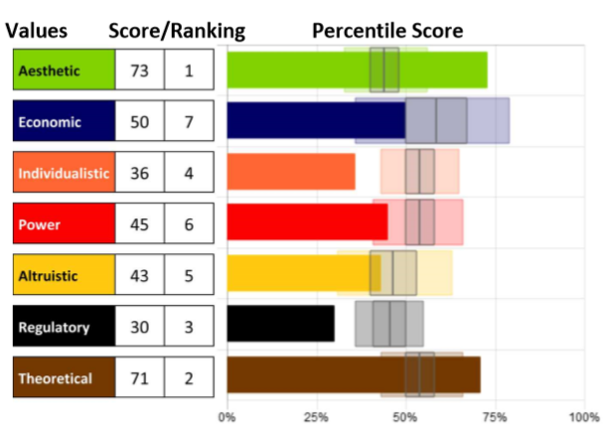
Knowing our specific level of
motivation can be crucial to
helping us understand what
drives our beliefs and actions so
we can bring them into
alignment.

Remember that although we can
explore each motivation
individually, they cannot be
separated. They can only be
distinguished; however, all motivators integrate to influence us.

The Economic Motivator - the drive for a return on investment

This motivation examines the need for security through self-interest,
economic gain, and to achieve real-world return on investment on
personal ventures (in various currencies, not just money).

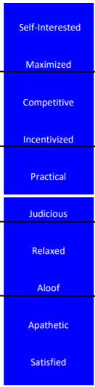
The approach is both personal and professional with a
focus on ultimate outcomes. This motivation is the need to
know “what’s in it for me”? A higher Economic score will
be future focused, competitive, agenda- driven, and
can be suspicious of others.

Using this descriptor scale, you can identify a key
component to each person’s score in this motivation, as
well as see how the scores range from Very Low to Very
High, noted by the black lines between each set of
descriptors. Each word represents 10 points of 100 on the
scale (example: Relaxed people score between 30-39,
Practical people score between 50-59 in this dimension).
The white line indicates 50%, perfect balance between high
and low in the motivation. Those who score closer to 50%
will be situational in applying this motivator. Moving further
from that line (high or low) indicates which areas are the more
influential.
Whether scores are high or low, the motivators with the furthest
distance above or below 50% (above or below “perfect balance” in
the center) will be the highest influencers leading to the greatest impact
on the decisions being made.

Strengths and Limitations
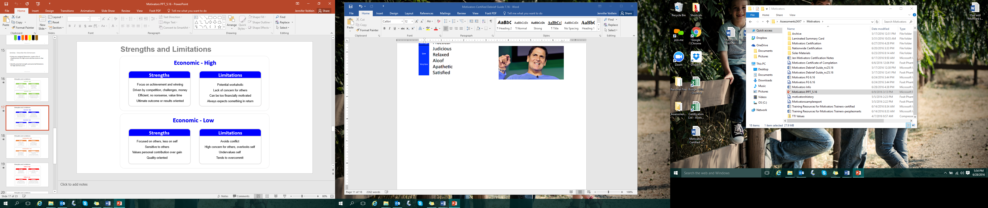

- What drives you in this motivation?
- How can that be helpful and productive for your goals?
- How can that limit you?

Assessments 24x7 LLC 5927 Balfour Court, Ste. 103 Carlsbad, California 92008 USA (206) 400-6647

